Algebra II
Unit 4 a - Radical Function
Date | Topic | Classwork | Homework
Mon  3/9 | ​4A.1 - Graph Radicals | Fold-able for graphing radicals & transformations  ​Power Point | Homework  Homework Answers
Tues  3/10 | ​4A.2 - Graph Radicals Practice | Power Point  Blank Notes  Completed Notes | Homework  Homework Answers
Wed  3/11 | ​ 4A.3 - Solve Radicals | Power Point  Completed Notes | Homework  Homework Guide​
Thurs  3/12 | ​4A.4 - Review | Review #1  ​Review #1 Answers | Review #2  ​Review #2 Answers
Fri  3/13 | Pi Day Party
Mon  3/16 | ​Unit 4A - Test | Test: Graphing and Solving Radical Equations | No Homework :)
Tues  3/17 | Midterm Review
Wed  3/18 | Midterm

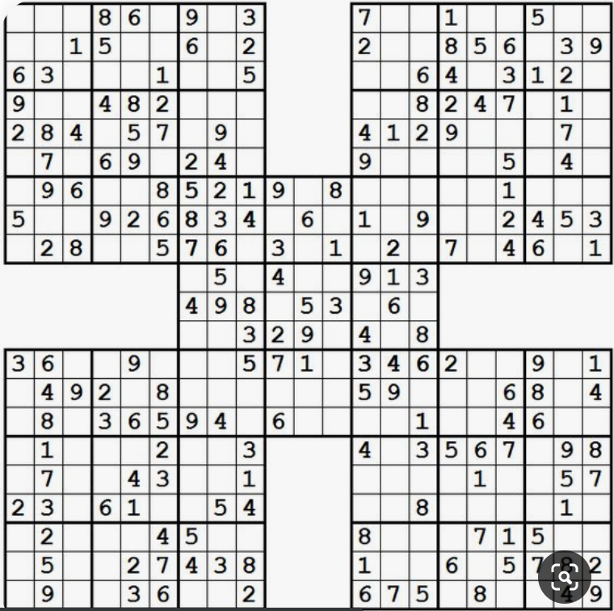
That’s an 8 and 4 that is covered up.

DeltaMath Suggested Pacing
Unit 4a - Radical Functions
- Transformations of Functions0/2
3/10
- Translate Functions (Level 1)0/3
- Transformations of Functions (Discovery)

- Radical Equations (Level 1)0/3
3/16
- Radical Equations (Level 2)0/3
- Radical Equations (Level 3)0/3
Due: Oct 04, 08:00 am

